Top Players Analysis

**Purpose:** Analysis was conducted on the FIFA 2019 dataset to find which players significantly outperformed their counterparts. Overall FIFA rating was metric used to conducted analysis.

**Descriptive Statistics:**

-N = 8,791

-Min, 1Q, Median, Q3, Max = 49, 61, 66, 71, 94

-Histogram shows performance relatively normal distribution that is slightly right skewed

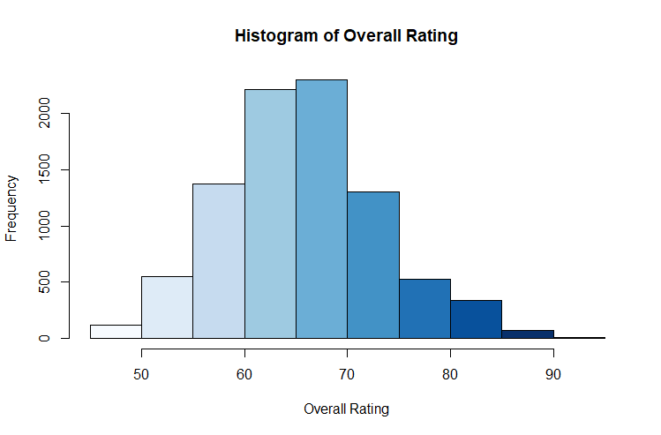

-Boxplot showed several outliers above the Q1 + 1.5IQR statistic

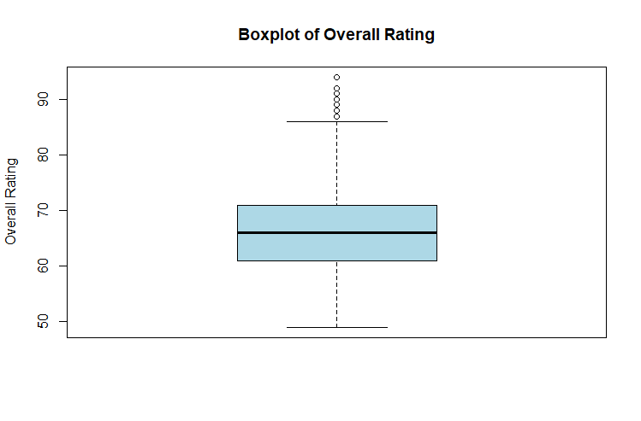

-Upper outlier based on the Q3 + 1.5IQR criteria = 86

**Analysis:** The upper outlier statistic of 86 was applied to the overall rating scores of the dataset. Any player possessing an overall score higher than 86 was deemed to be a top player.

**Insights:** Of the 8,791 players in the dataset, only 55 were determined to be top players. This of course means less than 1% of players in the world are considered top tier.